Children’s Advocacy Institute

CAN YOU SPARE 44 SECONDS?
KADEN, AGE 10, SPEAKS ON WHY IT IS IMPORTANT TO ENACT SB 504 (WIECKOWSKI)TO GET AN OBJECTIVE REPORT ON WHETHER ARTIFICIAL FOOD DYES ARE POSSIBLY HARMFUL TO OUR CHILDREN
If We Care About Kids, We Should Care About The Facts.
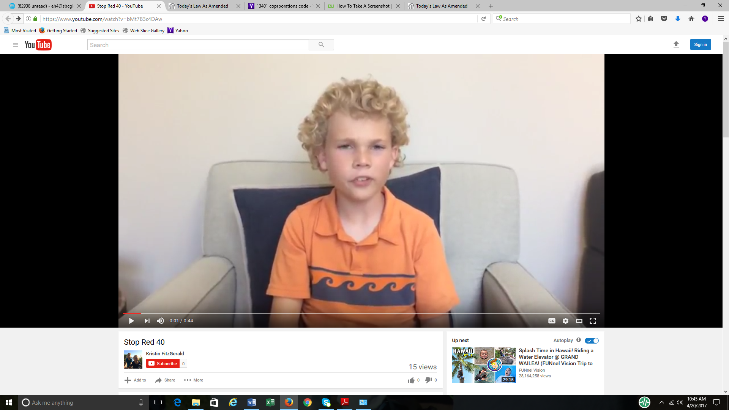
https://www.youtube.com/watch?v=bMt783c4DAw
“My symptoms when I eat food dye are diarrhea, stomach pain, or hyperactivity….
Halloween is really tough…There’s thousands of kids across the State with the same problem…”
THE CHEMICAL COMPANIES AND THEIR BUSINESS ALLIES ARGUED THAT A WARNING LABEL FOR FOOD CONTAINING ARTIFICIAL FOOD DYES IDENTICAL TO EUROPE’S WASN’T SCIENTIFICALLY-BASED.
SO, SENATOR WIECKOWSKI HAS AMENDED HIS SB 504 SIMPLY TO REQUIRE CALIFORNIA’S EXPERT AND RESPECTED AGENCY ON SUCH MATTERS TO REVIEW AND REPORT ON WHAT THE SCIENCE ABOUT CHILDREN AND FOOD DYES SAYS AND DOESN’T SAY.
DO WE CARE ENOUGH ABOUT KIDS TO GET THE FACTS?
Get the objective facts about children’s health: VOTE YES ON SB 504, AS AMENDED

