March 24, 2021

The Honorable Patrick O’Donnell
Chair, Assembly Education Committee
Honorable Members of the Committee
State Capitol, Room 4005
Sacramento, CA 95814

RE: Assembly Bill 740 (McCarty) – CO-SPONSORSHIP AND SUPPORT

Dear Chair O’Donnell and Honorable Committee Members:

The Children’s Advocacy Institute at the University of San Diego School of Law, which for 30 years has worked to improve the well-being of children in California through regulatory, legislative, and judicial advocacy, respectfully requests your support for AB 740 (McCarty), a bill that addresses a shocking and life-impairing injustice afflicting abused and neglected children; the children who are morally, legally, and uniquely, the responsibility of every Californian: foster children.

Education is essential to living a life of economic stability and self-sufficiency. A quality education system has long been understood as essential to every child’s prosperity. That is why the State guarantees free education to every child. The opposite is also true. When a child is denied educational opportunities, that child is being set-up for life-long failure, even the much-discussed “school-to-prison” pipeline.

Notwithstanding that foster youth are literally referred to as “children of the State,” we are failing to ensure that our own foster children stay in school in anything close to the numbers of children who remain with their parents. This is particularly true when it comes to Black foster children.

Consider: while statewide about 5% of boys are suspended, nearly a third of all Black male foster youth will be suspended during their school years. And, this is not just teenagers being suspended. Data show that a whopping 20% of Black foster youth in grades 4 through 6 are suspended.

Black foster youth in high school, nearing the end of their primary education and desperately in need of a high school diploma or GED, were more than seven times more likely than the average high school student to be suspended.

This chart establishes the rationale for the bill.
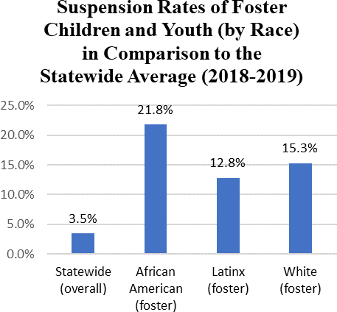

A child who is being parented by their legal parents, especially children of parents of means, have ready-made, emotionally motivated, and, often, competent advocates for them when it comes to suspensions and expulsions. Foster parents or guardians (often relatives of the parents) may lack the time, background, or expertise to advocate for the academic rights of the children in their care. Furthermore, students may cycle through multiple placements or be placed in group homes, which makes advocacy at school even less likely.

But, reliance upon foster parents for advocacy is unnecessary. Every child in foster care is already assigned a court appointed attorney to advocate on their behalf. Ensuring that a foster child’s attorney is notified of school discipline proceedings is a simple, the least-we-should-be-doing kind of step to safeguard the educational rights of these children; our children.

No class of children has suffered more and are suffering more as a result of the pandemic than foster children. A child who, for example, was immediately before the shut-down, placed in a setting that was supposed to be temporary has, instead, found themselves stranded with caretakers who were not supposed to have custody of the child for this length of time. Already abused and neglected and traumatized, they may have been physically disconnected from their brothers, sisters, aunts, uncles; their whole broader family during this frightening time.

Moreover, these children are not growing up in the long-run. They are growing up now. The decisions being made today regarding their education will place them on paths that may be life-long; irrevocable. Unsurprisingly, with their initial trauma compounded, they are acting out at school. They need the modest aid embraced by this bill and, please, they need it now.

As our own children, as children over whom we have asserted power and assumed total responsibility, as our most vulnerable and most disconnected children, they deserve no less than being a priority all the time, but, especially, during these troubled times.

For these reasons, CAI is honored to co-sponsor AB 740, and respectfully asks for your “aye” vote when it comes before you in the Committee.

Sincerely,

Ed Howard
Senior Counsel, Children’s Advocacy Institute

cc Hon. Members of the Committee

